**What is a salesforce CPQ?**

Salesforce CPQ is a software introduced by [Force.com](https://www.salesforce.com/products/platform/products/force/?d=70130000000f27V&internal=true) as a sales tool for the companies in providing accurate pricing for any product configuration scenarios. It also allows sales representatives to quote the prices of the products in a quick and accurate manner. It allows customizations, discounts, quantities & several optional features for the product during the sales procedures. It is easy to use on any device and will be available 24/7 as it is a cloud service platform hosted at Sales Cloud Platform providing you direct access to your CRM & decision making for impactful sales.

**A Quick Overview Of Salesforce CPQ Key Features**

**Product Configuration Features:**

* CPQ allows in creating product bundles with features and options. Features are defined as the categories for the bundle, and the options are defined as the components.
* Options are made as integral part of the bundle, and accessories or the related products also support for up-sell and cross-sell scenarios.
* Supports for exclusion and inclusion rules which are option constraints.
* CPQ also supports for hiding of the components or dynamic addition of components for the bundle which is being configured.

#### The Pricing Features

##### CPQ provides multiple pricing scenarios, few of them are:

* **Contract Pricing** - In the process of discounting/pricing, margin calculation is also shown for the end user.
* **Cost + Markup pricing** - It supports for product costs in addition for price.
* **Block Pricing** - Eg:, If the price of 1-25 products is 50USD and 25-50 products could be 100USD, there will be option for tier based discounting. (1-25 products at 5% discount  and 25-50 products with 10% discount)
* Real-time price processing for targeting a price to the solution bundles.

**The Quoting Features:**

* Generation of integrated quote document.
* Process for integration of E-Signature tools.
* Customization of quote templates for various sections that are to be configured i.e, header, quote line, footer & quote terms also.

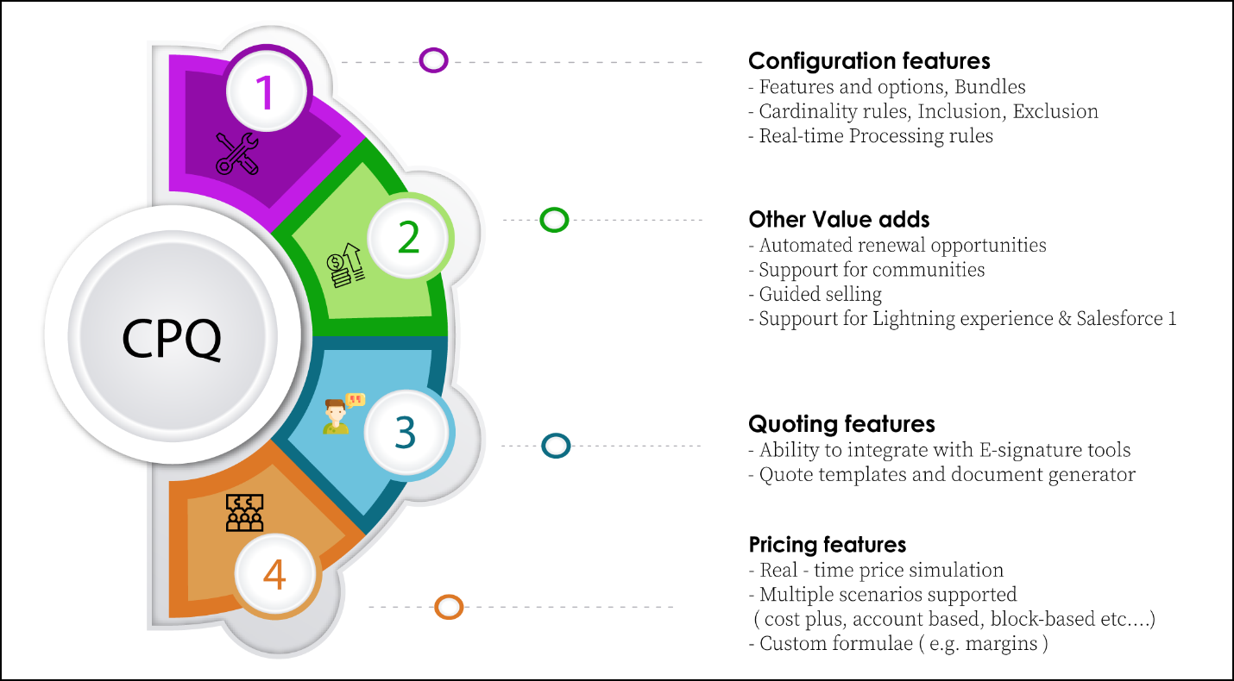

**The Productivity Features:**

* It provides customization in search process of products.
* Capacity for scripting questions & guide the sales user and customer for the best possible product fit.

**Other Added Features:**

* Provides renewal opportunities for automatic generation which drives the accurate pipeline projection for the sales team to timely follow up.
* The product availability in the **Lightning Experience**.
* The availability for Salesforce1 mobile.
* Supports the partners and customers in enabling access for CPQ functionality.

### What is Salesforce CPQ Process Flow?

As mentioned earlier, Salesforce CPQ helps in the complexity of Quoting and functional proposal process by the team and have an analysis of the year-to-year growth rate of the revenue. Few other added features are:

* Product Configuration.
* Pricing features.
* Quoting features.
* Productivity features.

Coming to the technical part of integrating and installation of the software, there are several developers available in the market who have hands-on experience on the process. And, there is a support portal from the Salesforce domain itself for the **Salesforce CPQ** product pricing and for related query clarification.